Samuel Bernheim (bernheim@brandeis.edu) 2016-3-9

Problem 3.12

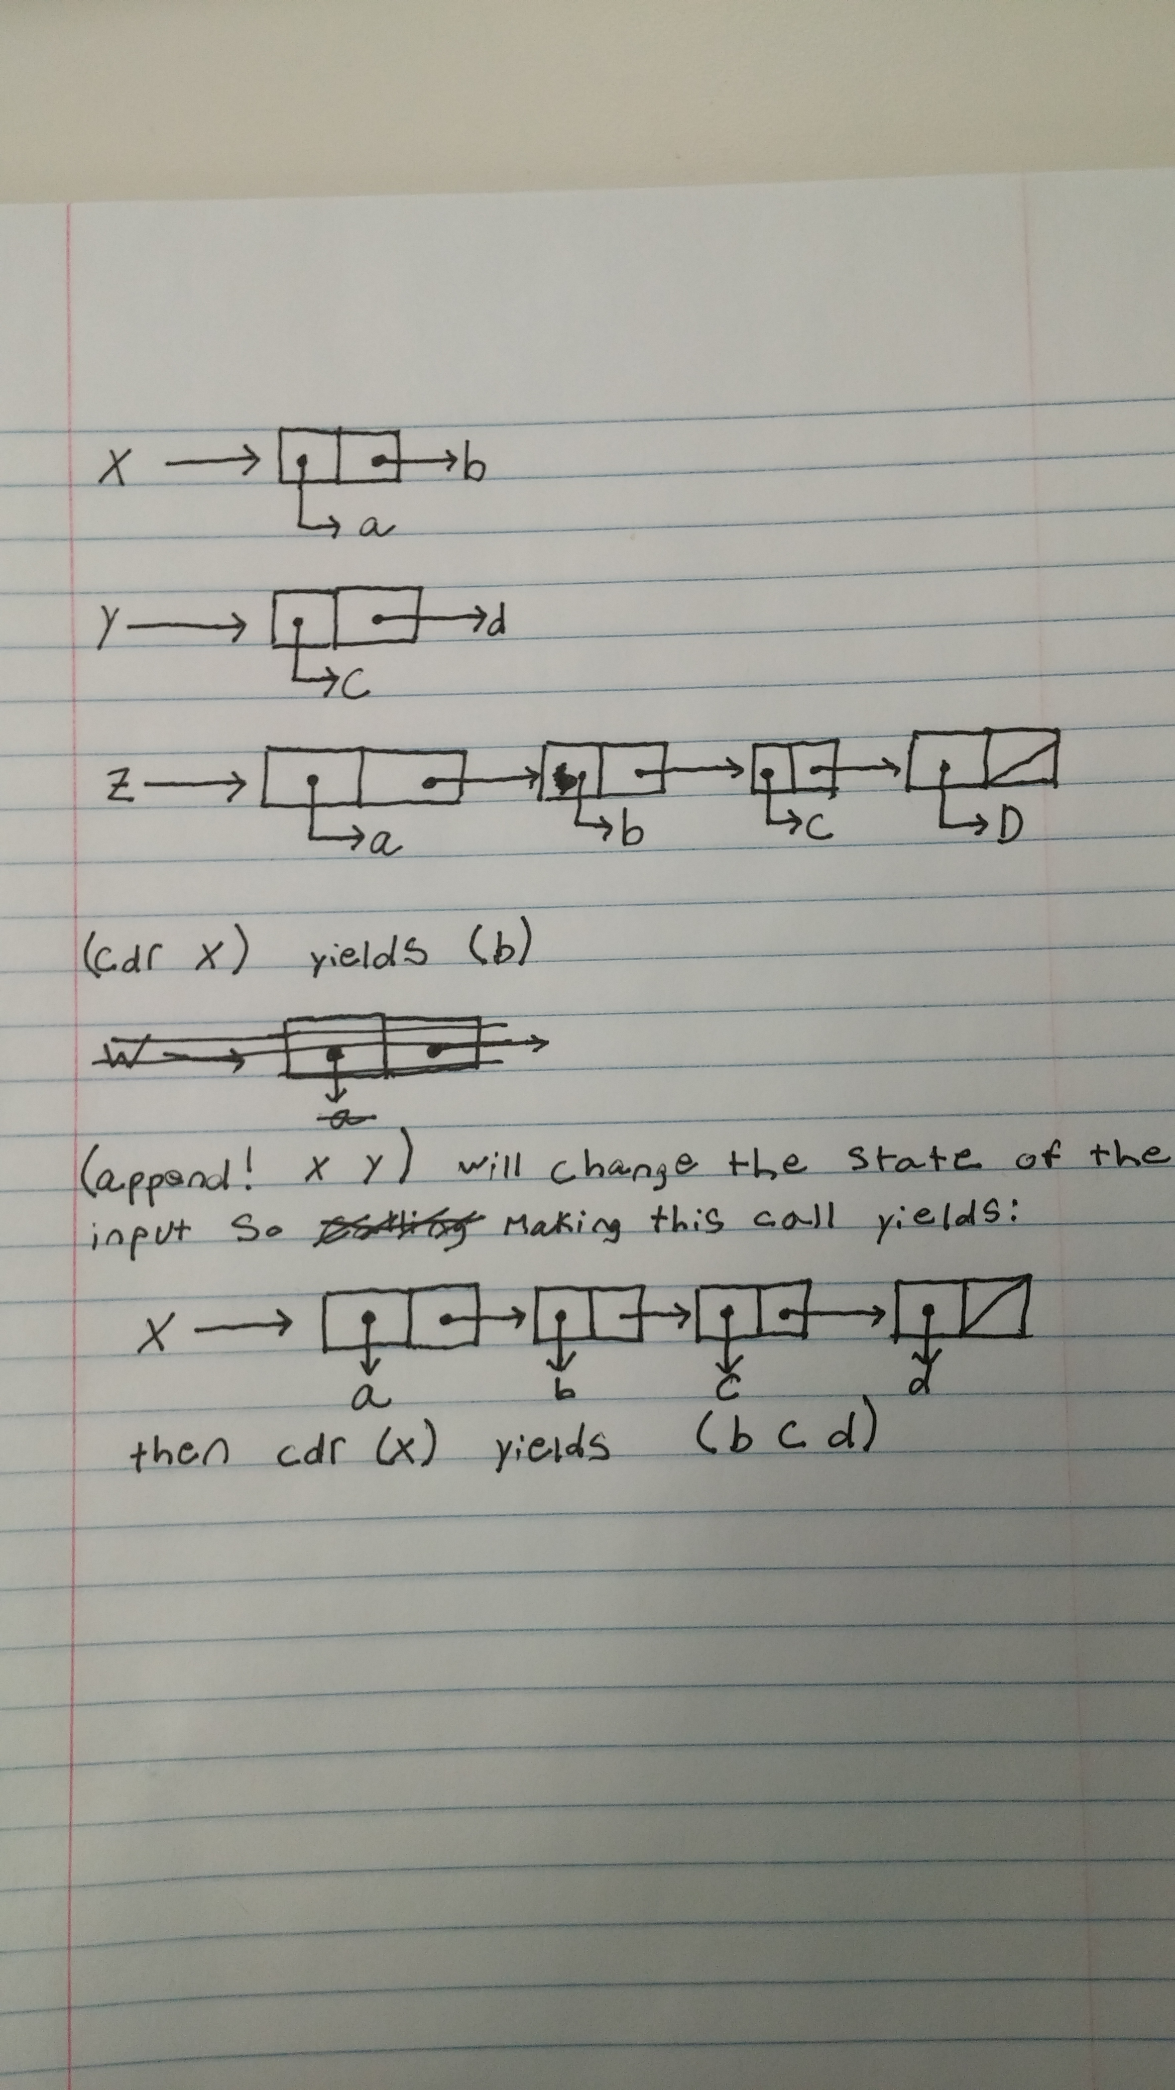

Problem 3.14

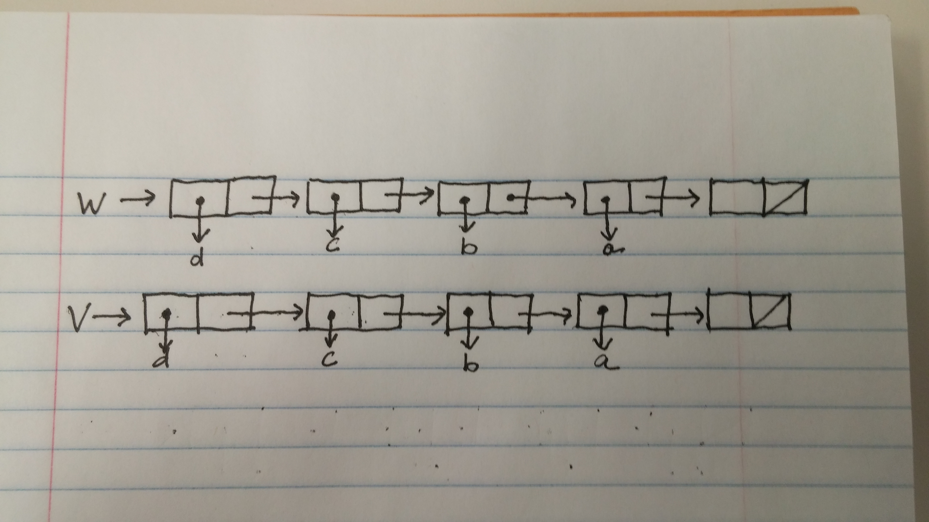

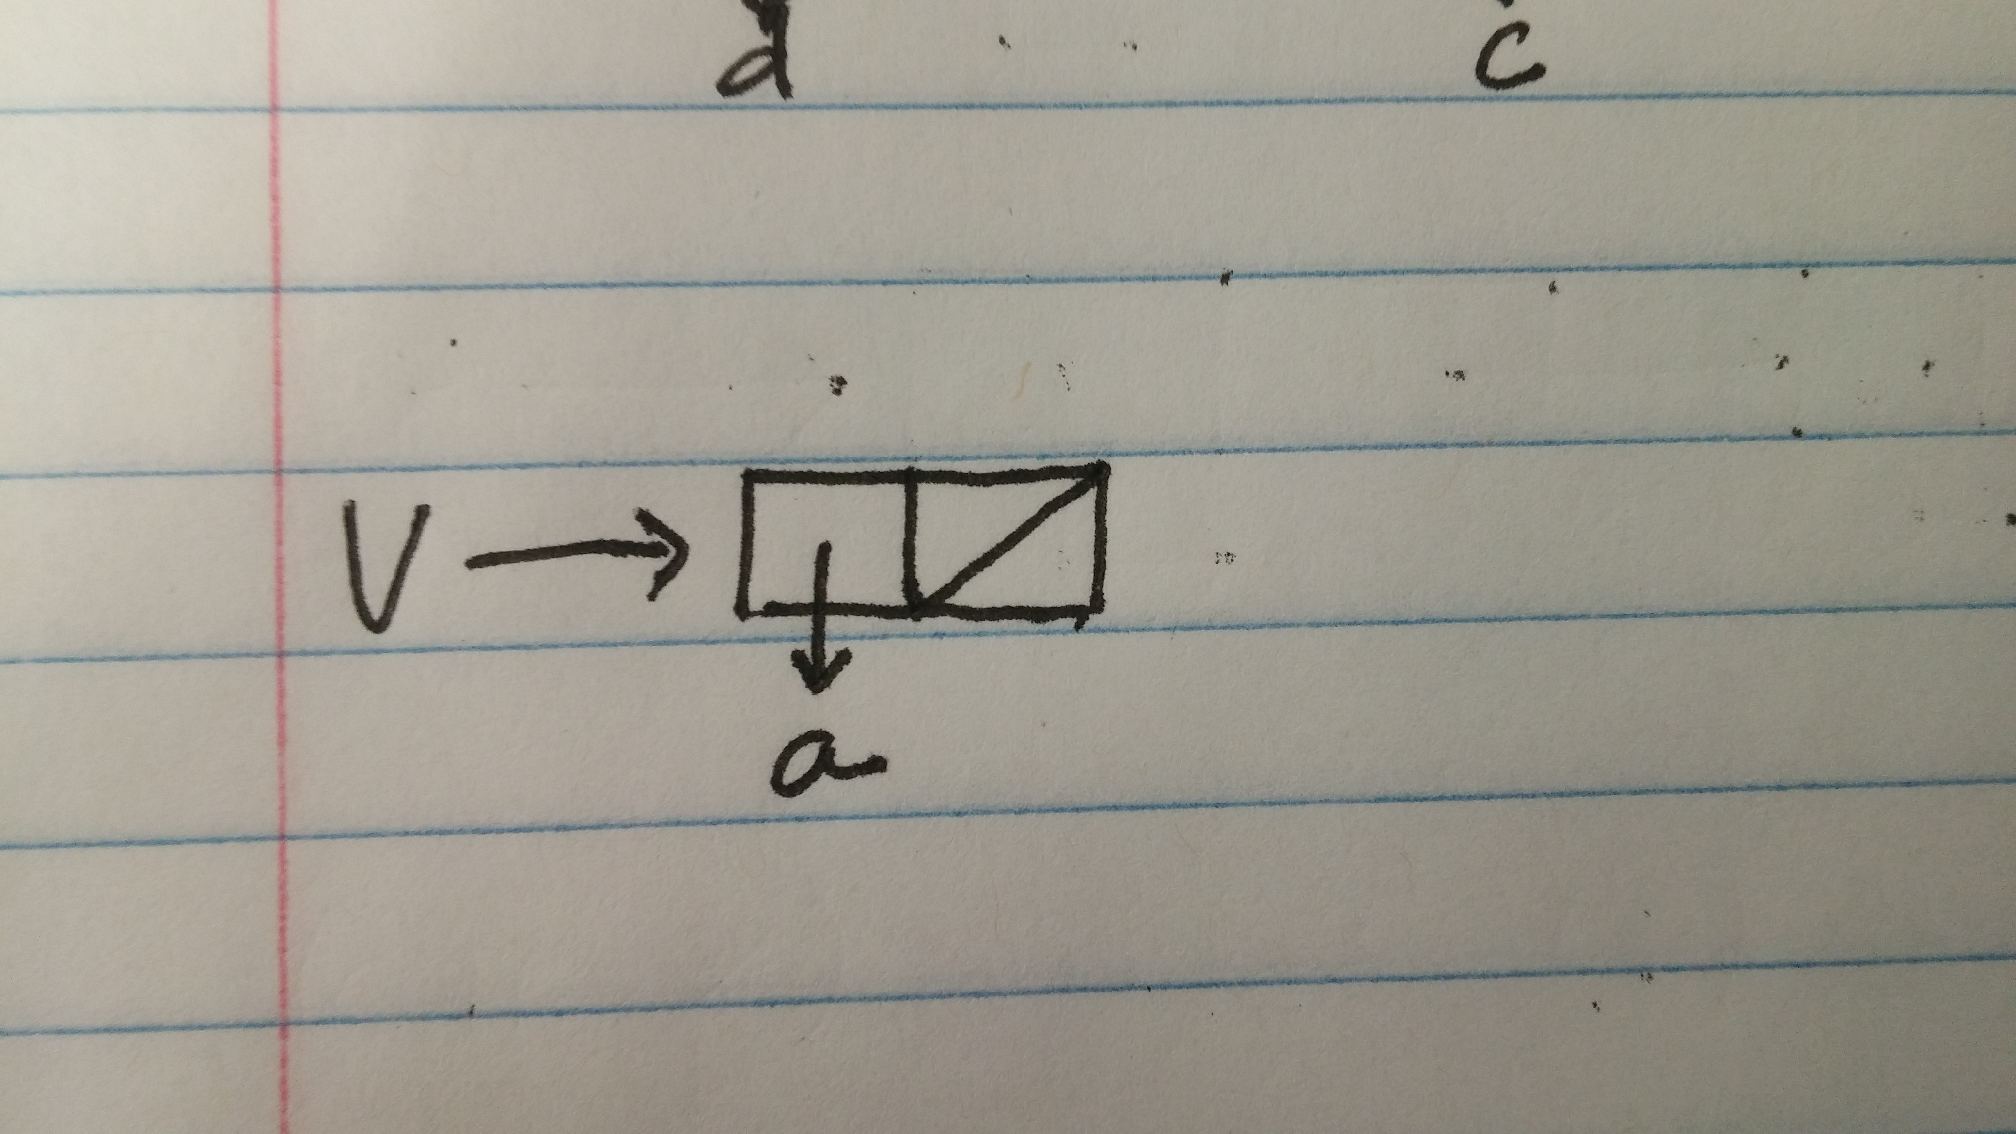

Printing v would result in (a). Printing w would result in (d c b a).